- This week's UK labour market and GDP releases suggested that momentum in the economy remains very sluggish. HMRC's count of payrolled employees stabilised in September, while GDP has been broadly flat in recent months. Given the strength of domestic headwinds facing the economy, we expect these underwhelming conditions to carry through to 2026.
- In remarks at the IMF meetings, Bank of England Governor Andrew Bailey struck a relatively balanced tone and offered little pushback against financial market pricing, which currently implies a slim chance of a rate cut in November.
Noisy data, revisions to past outturns, and ongoing reliability concerns made interpreting this week's two major releases a challenge. But on balance, we're still confident in our assessment that momentum in the economy remains sluggish, while conditions in the labour market continue to cool very gradually.
The Office for National Statistics reported that headline (three-month average of the annual rate) private sector regular pay growth slowed to 4.4%, from 4.7% in July. The three-month-on-three-month annualised rate – a better guide to recent momentum – was softer still, which should pull the headline rate down further in the coming months.
The data on labour market quantities were more mixed. The unemployment rate ticked up in the three months to August, but this was driven by an unusually high single-month reading for August. We see this volatility as further evidence that the ONS is a long way from resolving its data quality issues.
HMRC's count of the number of employees on payrolls offers a more reliable and timelier read on conditions in the jobs market, and this week's release suggested that job losses may be starting to bottom out. Indeed, though HMRC reported a 10,000 m/m fall in payrolled employees in September, this came after an upwardly revised 10,000 increase in jobs in August. Given the tendency for early estimates to be revised up, there's some tentative evidence that the drag from April's employee national insurance contributions increase is beginning to fade (Chart 1).
Chart 1: HMRC's latest count of payrolled employees points to a stabilising jobs market
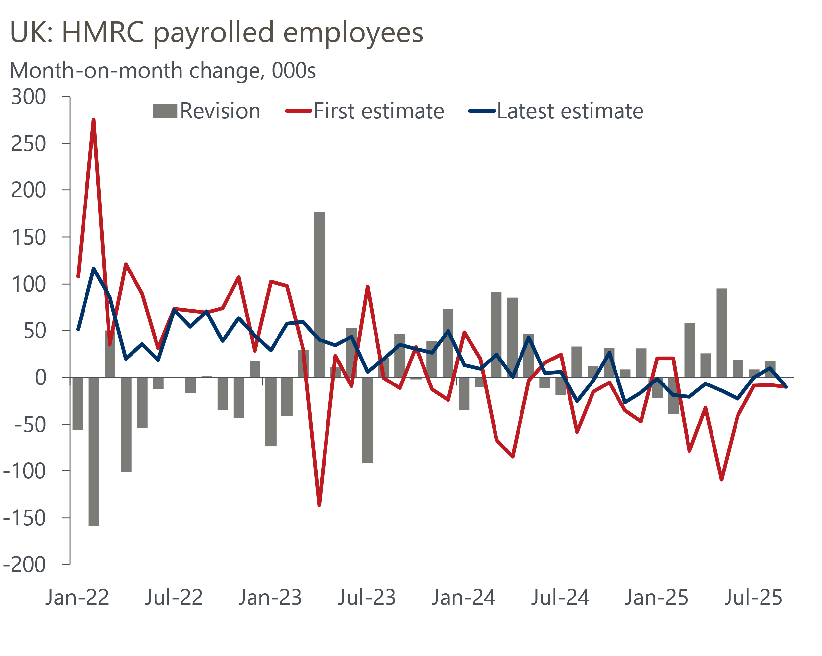
Source: Oxford Economics calculations using data from ONS

The labour market is flatlining and this week's other major release painted a similar picture for GDP. The ONS reported that output grew 0.1% m/m in August, having fallen by a downwardly revised 0.1% in July. At the sector level, the drag in July from weaker services and manufacturing activity unwound in August. These gains were more than enough to make up for a modest fall in construction output.
Looking at how GDP has evolved so far this year, what stands out is that growth has shifted down a gear after a very strong start to 2025. We think the monthly GDP series continues to show evidence of residual seasonality, with data for the first eight months of 2025 tracking the seasonal pattern of recent years, where strong growth at the start of the year is followed by an abrupt slowdown. When we also factor in the strength of domestic headwinds facing the economy, this suggests growth is likely to remain sluggish through the rest of this year and into 2026.
At recent meetings, the Monetary Policy Committee suggested it was less concerned than it had been in early summer about the resilience of the labour market, and there was no new reason for alarm in this week's data. GDP growth is likely to be in line with the MPC's expectations in Q3. And though private sector regular pay growth might be a touch softer than the MPC anticipated, the committee has been clear that it's more focused on the lack of passthrough from slowing pay growth to services inflation. The MPC will likely need to see material progress on this front before a majority will be willing to back calls for rate cuts to resume (Chart 2).
Chart 2: Measures of underlying services inflation remain very sticky, despite cooling pay growth
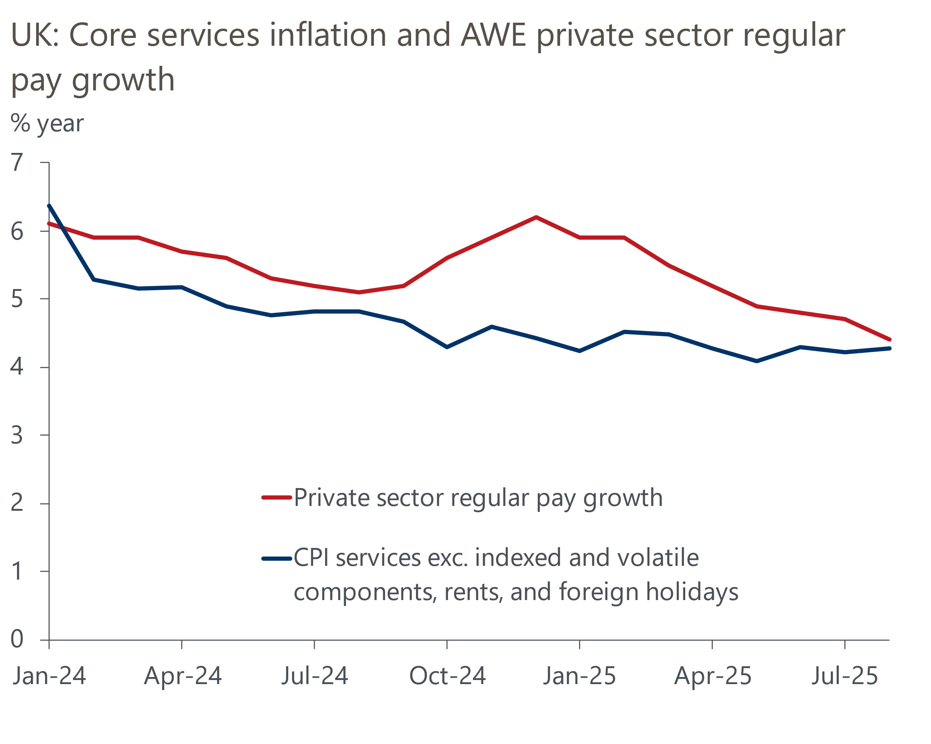
Source: Oxford Economics calculations using data from Haver Analytics
Several MPC members spoke at the IMF's annual meetings this week. Catherine Mann and Megan Greene reiterated existing concerns that policy restrictiveness should be maintained to mitigate the upside risks to inflation from higher inflation expectations. But in an event in the UK, Alan Taylor suggested that he still sees the "upside risks to inflation as low compared to the downward trajectory in output and inflation fundamentals".
Governor Andrew Bailey has emerged as the committee's 'swing voter', and he struck a relatively balanced tone at the IMF this week, highlighting the competing threats from a softening labour market and above-target inflation. The lack of pushback from Bailey against financial market pricing, which currently implies just a 9% chance of a 25bp rate cut in November, means we're comfortable sticking with our forecast that the well-established cut-hold pattern will come to an end.
Forecasting subsequent meetings is made harder by the upcoming Budget. Chancellor Rachel Reeves hinted this week that the Budget will contain spending cuts alongside widely expected tax rises. There's also growing speculation that the Chancellor will seek to improve her slim headroom against her fiscal rules to guard against future shocks. Though increased headroom and spending cuts are likely to prove politically challenging, we think they would represent an important step towards reassuring markets that the foundations of her Budget are not solely resting on a series of narrow tax hikes, where the amounts of revenues raised are highly uncertain.

The week ahead
We estimate that CPI inflation rose to 4% in September, from 3.8% in August. Base effects are likely to be the main cause of the pickup, particularly from the fuel category. Weekly data from the Department of Energy Security and Net Zero suggests that petrol prices fell 0.2% between August and September, compared to a 3.9% drop over the same period in 2024. Meanwhile, some modest upward pressure from the core category is also likely, partly reflecting a large positive base effect in the notoriously volatile air fares sub-category.
The retail sector performed very strongly over the summer, with sales volumes rising 1.4% between May and August. But it's difficult to see this pace being sustained, particularly in the non-food and non-store sub-sectors where recent outturns have left the level of sales well above previous trends. So we think there's a good chance that some of this outperformance will unwind, and pencil in a 0.2% month-on-month fall for September.
September's S&P Global surveys reported a large fall in the composite PMI and suggested that private sector activity growth ground to a halt. We suspect this partly reflected a course correction after an implausibly large bounce in August, as well as weaker business sentiment ahead of virtually inevitable tax rises in the upcoming Budget. Some normalisation of conditions in the services sector and the partial reopening of factories in the automotive sector mean we think the composite PMI will rise to 50.9 in October's flash survey.
Table 1: Week ahead calendar
Date | Events | Period | Measure | Unit | Previous | Forecast
Oct 21 | Public finances | Sep | PSNB ex | £bn | 18.0 | 20.5
Oct 22 | CPI inflation | Sep | m/m | % | 0.3 | 0.1
Oct 22 | CPI inflation | Sep | y/y | % | 3.8 | 4.0
Oct 22 | RPI inflation | Sep | m/m | % | 0.4 | 0.1
Oct 22 | RPI inflation | Sep | y/y | % | 4.6 | 5.1
Oct 24 | GfK consumer confidence | Oct | Headline | % bal | -19 | -17
Oct 24 | Retail sales inc fuel | Sep | m/m | % | 0.5 | -0.2
Oct 24 | Retail sales inc fuel | Sep | y/y | % | 0.7 | 0.6
Oct 24 | S&P Global manufacturing | Oct | PMI | % bal | 46.2 | 46.8
Oct 24 | S&P Global services | Oct | PMI | % bal | 50.8 | 51.6
Oct 24 | S&P Global composite | Oct | PMI | % bal | 50.1 | 50.9
Source: Oxford Economics

Key forecasts
Table 2: UK forecast overview
(Annual percentage changes unless specified)
 | 2023 | 2024 | 2025 | 2026 | 2027 | 2028
GDP | 0.3 | 1.1 | 1.5 | 0.9 | 1.3 | 1.7
Private consumption | -0.3 | -0.2 | 1.0 | 1.1 | 1.1 | 1.7
Fixed investment | 0.5 | 1.8 | 2.1 | 0.5 | 1.5 | 2.0
Government consumption | 2.1 | 3.4 | 2.1 | 1.7 | 1.6 | 1.7
Exports of goods and services | -2.3 | 0.7 | 2.9 | -0.2 | 1.2 | 1.5
Imports of goods and services | -1.6 | 2.6 | 3.4 | -0.3 | 1.2 | 1.5
Industrial production | -2.6 | -1.6 | -0.4 | -0.1 | 1.1 | 1.4
Consumer prices | 7.3 | 2.5 | 3.5 | 2.8 | 2.5 | 2.2
Unemployment rate (%) | 4.1 | 4.3 | 4.7 | 4.9 | 4.8 | 4.4
Current a/c balance (% of GDP) | -3.6 | -2.2 | -3.1 | -2.8 | -2.5 | -2.4
Government balance (% of GDP) | 5.2 | 5.1 | 4.7 | 3.7 | 3.1 | 2.7
Central bank policy rate (%, EOP) | 5.25 | 4.75 | 4.00 | 3.50 | 3.00 | 2.75
10yr govt. bond yield (%, EOP) | 3.54 | 4.57 | 4.70 | 4.28 | 3.80 | 3.51
Exchange rate (US$ per £, EOP) | 1.27 | 1.25 | 1.34 | 1.34 | 1.34 | 1.34
Exchange rate (euro per £, EOP) | 1.15 | 1.21 | 1.15 | 1.15 | 1.15 | 1.15
Source: Oxford Economics
Table 3: Quarterly forecasts for the UK
 | 2025 |  |  |  | 2026
 | Q1 | Q2 | Q3 | Q4 | Q1 | Q2 | Q3 | Q4
GDP (% year) | 1.7 | 1.4 | 1.4 | 1.3 | 0.9 | 0.9 | 0.9 | 1.0
CPI inflation (% year) | 2.8 | 3.5 | 3.9 | 3.7 | 3.4 | 2.6 | 2.6 | 2.6
Bank Rate (%, EOP) | 4.50 | 4.25 | 4.00 | 4.00 | 3.75 | 3.75 | 3.50 | 3.50
10yr gilt yield (%, EOP) | 4.70 | 4.48 | 4.70 | 4.70 | 4.69 | 4.58 | 4.44 | 4.28
US$ per £ (EOP) | 1.29 | 1.37 | 1.35 | 1.34 | 1.34 | 1.34 | 1.34 | 1.34
Euro per £ (EOP) | 1.20 | 1.17 | 1.15 | 1.15 | 1.15 | 1.15 | 1.15 | 1.15
Source: Oxford Economics

Latest Country Economic Forecast:
October 13, 2025

Recent publications

Data Insights
GDP grew modestly in August, but the outlook remains subdued
Labour market helps to keep Bank of England on hold
Services sector vulnerable to the Budget uncertainty
Manufacturing sector remains fragile
GDP growth hides more weakness

Research Briefings
What happens if markets lose faith in the fiscal approach?
What will the Chancellor do in the Budget?
Fiscal fragility could reveal sterling's vulnerability
MPC follows path of least resistance on quantitative tightening
MPC preview – Pace and shape of QT is likely to be tweaked

Contacts

Oxford Economics' UK team
- Andrew Goodwin - Chief UK Economist - agoodwin@oxfordeconomics.com
- Edward Allenby - Senior UK Economist - eallenby@oxfordeconomics.com

